**CPTS583**

**Deliverable 3-1**

Preliminary requirements of a librarian assistant:

* Secure user registration and management
* Secure librarian privileges to access general registered users
* Efficient book search
* Easy-to-use user interface for placing a hold, checking out, and returning a book

Some understanding of their work:

* Easy to setup by following README
* Using Flask as web framework which is easy to maintain
* The product has four web pages with simple text content which are easy to learn
* Using Bcrypt to encrypt data transmission for security
* Implemented function: user register and login, checking out a book, returning a book, and show list of books.

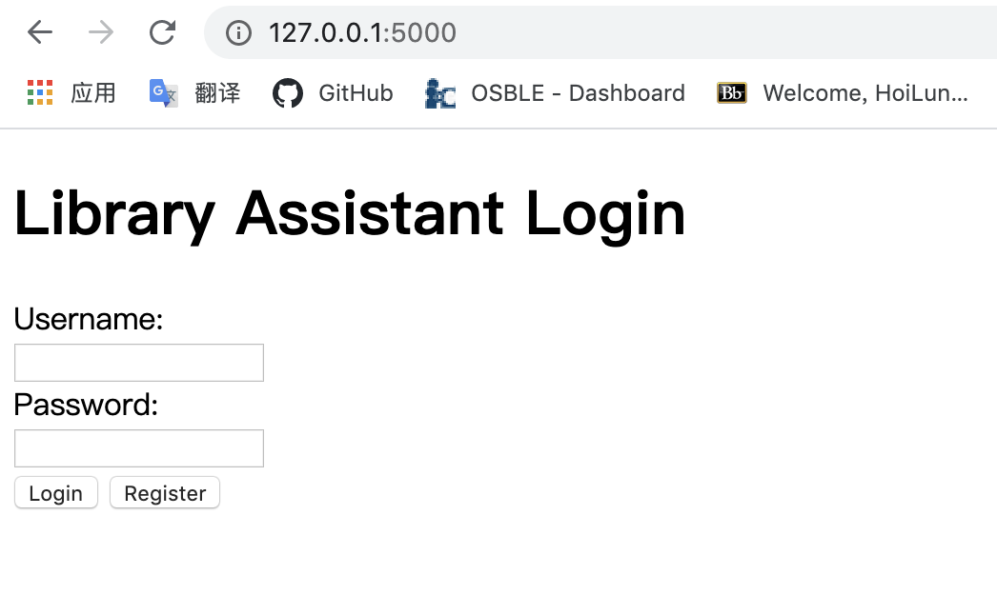

Register and login

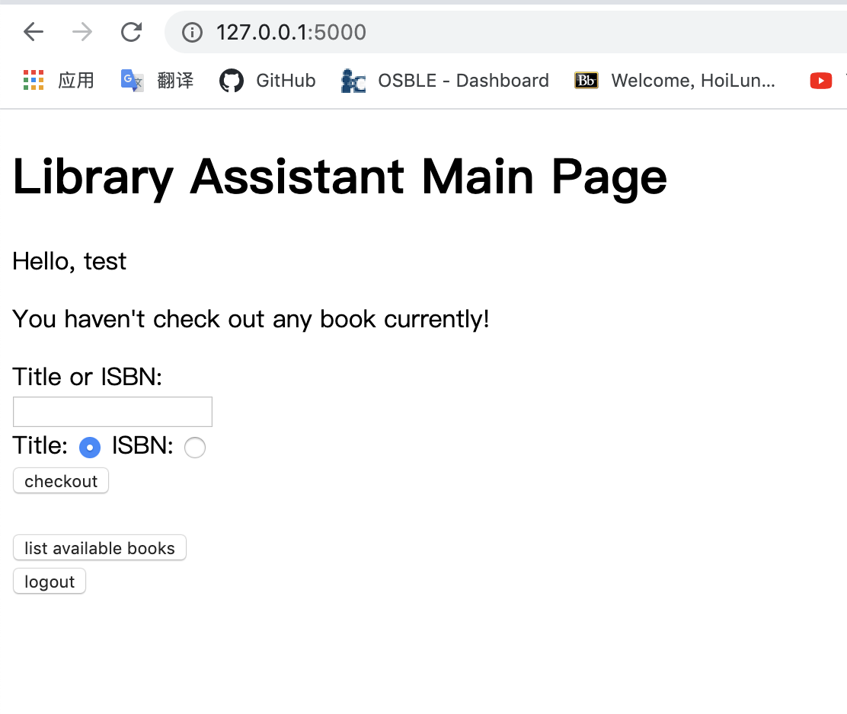

Main page

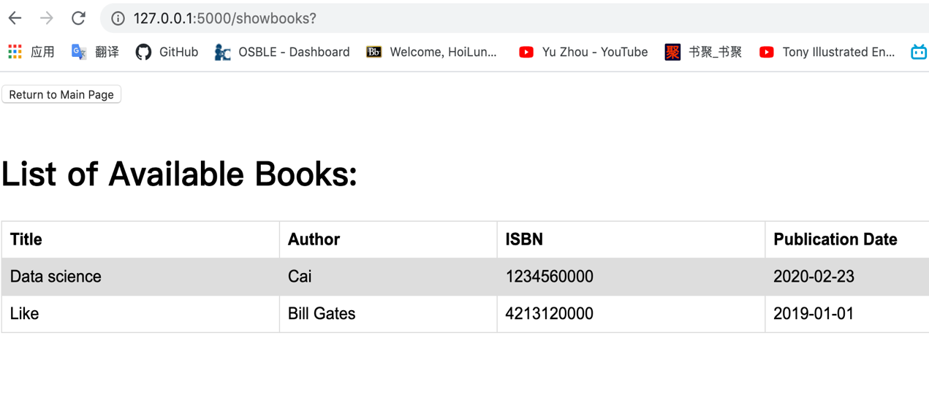

List of books

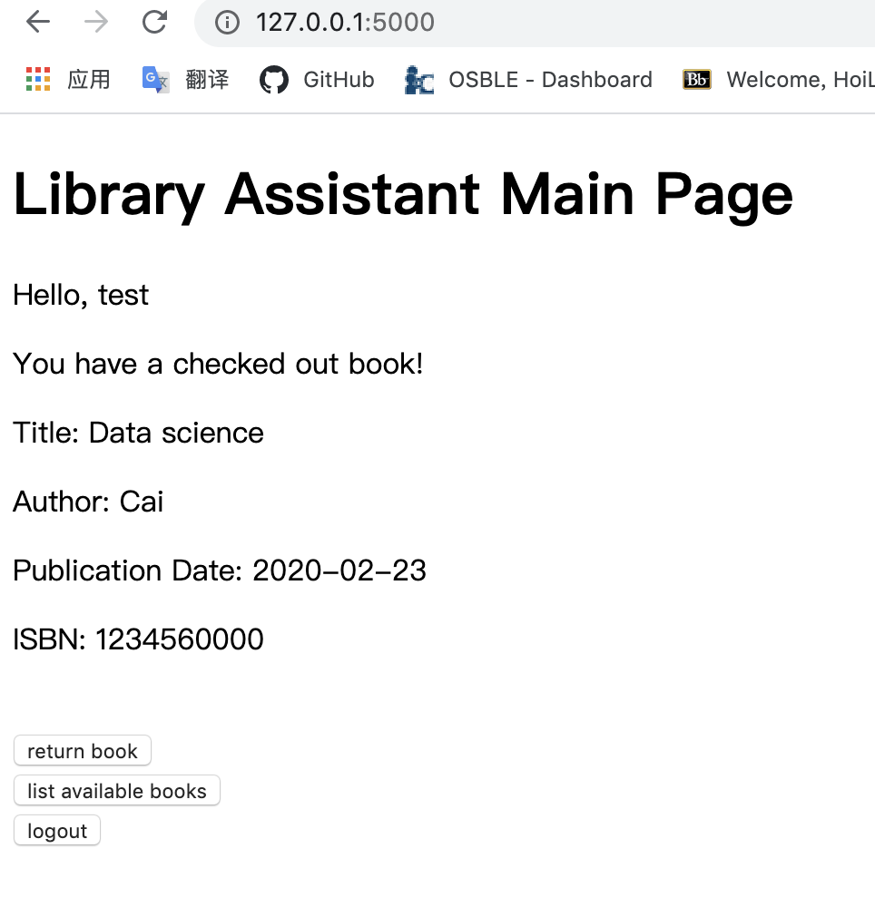 checking out a book

Preparation for Deliverable 3-2

* Use the test cases or other quality evaluation software to evaluate whether it satisfied the quality metrics or not